### “Simple Automated Teller Machine”

### OBJECT ORIENTED PROGRAMMING[18CSC263J]

### A PROJECT REPORT

*Submitted by*

**Katha Sai Indra Reddy[Reg No: RA2111042010021]**

**V. Nitesh Reddy [Reg No: RA2111042010016]**

**K. Nitin Thomas [Reg No: RA2111042010006]**

*Under the Guidance of*

### Dr. PAUL T SHEEBA

#### (Assistant Professor, Department of Data Science and Business Systems)

*In partial fulfillment of the Requirements for the Degree of*

## BACHELOR OF TECHNOLOGY COMPUTER SCIENCE AND BUSINESS SYSTEMS

**DEPARTMENT OF DATA SCIENCE AND BUSINESS SYSTEMS**

## FACULTY OF ENGINEERING AND TECHNOLOGY SRM INSTITUTE OF SCIENCE AND TECHNOLOGY NOVEMBER 2022



**COLLEGE OF ENGINEERING AND TECHNOLOGY**

**SRM INSTITUTE OF SCIENCE AND TECHNOLOGY**

(under Section 3 of UGC Act,1956)

**SRM NAGAR, KATTANKULATHUR -603 203**

**CHENGALPATTU DISTRICT**

# **BONAFIDE CERTIFICATE**

**Register No:RA2111042010016**

Certified to be the bonafide record of work done by **V. Nitesh Reddy** of **III Semester** , B.Tech **COMPUTER SCIENCE AND BUSINESS SYSTEMS** Degree course in the Practical **18CSC263J-OBJECT ORIENTED PROGRAMMING** in **SRM**  **INSTITUTE OF SCIENCE AND TECHNOLOGY, Kattankulathur** during the academic year 2022-2023

**Lab In-charge**

**Date: Head of Department**

Submitted for University Examination held in___________________________,

**SRM INSTITUTE OF SCIENCE AND TECHNOLOGY,**  **Kattankulathur.**

Date: Examiner-1 Examiner-2

**ABSTRACT**

**ATM SYSTEM**

The **ATM System** is the project which is used to access their bank accounts in order to make cash withdrawals. Whenever the user need to make cash withdraws, they can enter their PIN number (personal identification number) and it will display the amount to be withdrawn in the form of 100’s 500’s and 1000’s. Once their withdrawn was successful, the amount will be debited in their account.

The ATM System is developed in VB.Net and back-end database as Ms-Access. VB.Net is the one of the powerful version of Framework and object oriented programming. Hence we use this software in our project.

The ATM will service one customer at a time. A customer will be required to enter ATM Card number, personal identification number (PIN) – both of which will be sent to the database for validation as part of each transaction. The customer will then be able to perform one or more transactions. Also customer must be able to make a balance inquiry of any account linked to the card.

The ATM will communicate each transaction to the database and obtain verification that it was allowed by the database. In the case of a cash withdrawal, a second message will be sent after the transaction has been physically completed (cash dispensed or envelope accepted).  If the database determines that the customer’s PIN is invalid, the customer will be required to re-enter the PIN before a transaction can proceed.

If a transaction fails for any reason other than an invalid PIN, the ATM will display an explanation of the problem, and will then ask the customer whether he/she wants to do another transaction.

The ATM will provide the customer with a printed receipt for each successful transaction, showing the date, time, machine location, type of transaction, account(s), amount, and ending and available balance(s) of the affected account (“to” account for transfers).

### ACKNOWLEDGEMENTS

We express our humble gratitude to **Dr C. Muthamizhchelvan**, Vice-Chancellor, SRM Institute of Science and Technology, for the facilities extended for the project work and his continued support. We extend our sincere thanks to Dean-CET, SRM Institute of Science and Technology, **Dr T.V.Gopal**, for his invaluable support.

We wish to thank **Dr Revathi Venkataraman**, Professor & Chairperson, School of Computing, SRM Institute of Science and Technology, for her support throughout the project work. We are incredibly grateful to our Head of the Department**, Dr M. Lakshmi** Professor, Department of Data Science and Business Systems, SRM Institute of Science and Technology, for her suggestions and encouragement at all the stages of the project work. We want to convey our thanks to our program coordinator **Dr.E.Sasikala,** Professor, Department of Data Science and Business Systems, SRM Institute of Science and Technology, for her input during the project reviews and support.

We register our immeasurable thanks to our Faculty Advisor**, Dr. R Rajkumar,** Assistant Professor, DSBS, SRM Institute of Science and Technology, for leading and helping us to complete our course.

Our inexpressible respect and thanks to my guide, **Dr. Paul T Sheeba,** Assistant Professor, DSBS, SRM Institute of Science and Technology, for providing me with an opportunity to pursue my project under his mentorship. He provided me with the freedom and support to explore the research topics of my interest. His passion for solving problems and making a difference in the world has always been inspiring. We sincerely thank the Data Science and Business Systems staff and students, SRM Institute of Science and Technology, for their help during our project. Finally, we would like to thank parents, family members, and friends for their unconditional love, constant support, and encouragement.

**TABLE OF CONTENTS**

CHAPTER.NO TITLE PAGE.NO

1 INTRODUCTION

1.1 Limitations

1.2 Approach/methodology

1.3 Modules

2 System design and implementation

2.1 ZERO LEVEL DATA FLOW DIAGRAM (0 LEVEL DFD)

2.2 FIRST LEVEL DATA FLOW DIAGRAM (1 LEVEL DFD)

2.3 SEQUENTIAL DIAGRAM

2.4 COLLABRATION DIAGRAM

2.5 USECASEDIAGRAM   
2.6 STATE CHART DIAGRAM

2.7 SOURCE CODE

3 Output

4 Conclusion and future enhancement

**Chapter 1**

**Introduction to the ATM system:**

Automated Teller Machine enables the clients of a bank to have access to their account without going to the bank.  This is achieved only by development the application using online concepts.

When the product is implemented, the user who uses this product will be able to see all the information and services provided by the ATM, when he enters the necessary option and arguments.  The product also provides services like request for cheques, deposit cash and other advanced requirement of the user.  The data is stored in the database and is retrieved whenever necessary.  The implementation needs ATM machine hardware to operate or similar simulated conditions can also be used to successfully use the developed product.

To develop this ATM system the entire operation has been divided into the following step:

1. verification process
2. language, service and account selection
3. Banking services
4. Transactions
5. Special services

The program is designed in such a way that the user has to card and pin number.  Once verified, he is provided a menu and he/she had to enter the option provided in the menu.  For example, when the user wants to view the list of payment history than he/she had to enter the option for payment history provided in the main menu.  When the option is entered alone with the respective argument, then the payment history is displayed on the screen.

The user also must be given option to browse through the pages like previous page, next page, etc.  The user may experience a delay in retrieving or viewing the data, when there are many users logged on to the same bank branch system.

**CHAPTER 2**

**System Design and implementation**

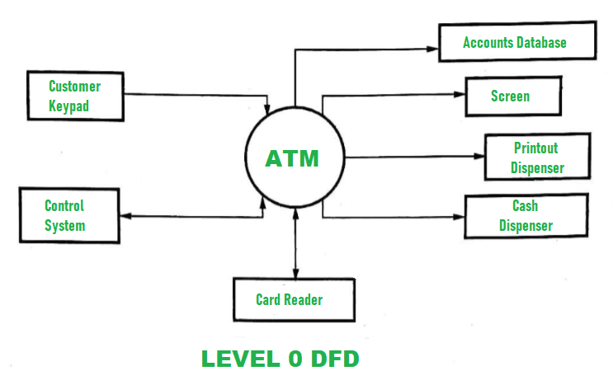**2.1 ZERO LEVEL DATA FLOW DIAGRAM OF MINI VOTING SYSTEM (0 LEVEL DFD):**

**2.2 FIRST LEVEL DATA FLOW DIAGRAM OF MINI VOTINGSYSTEM (1st LEVEL DFD):**

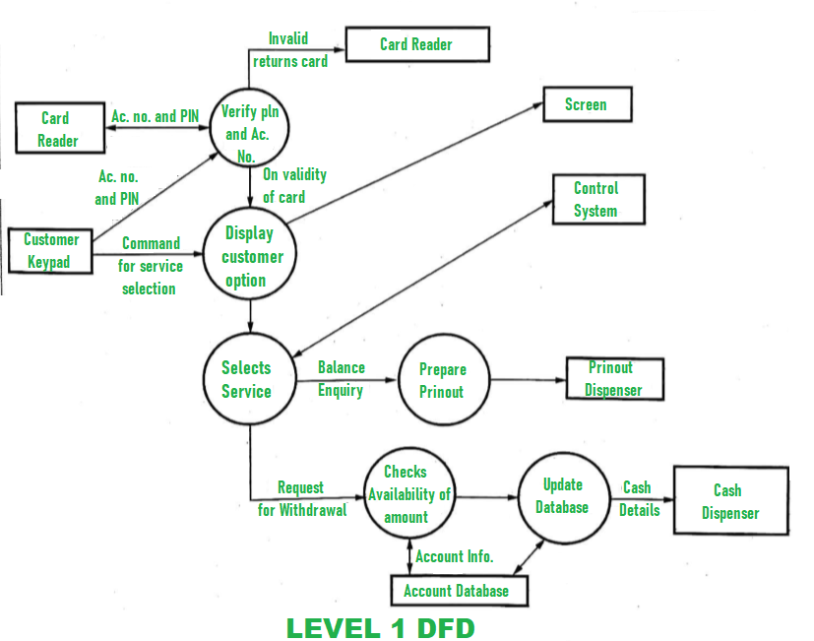

**2.3 SEQUENTIAL DIAGRAM** 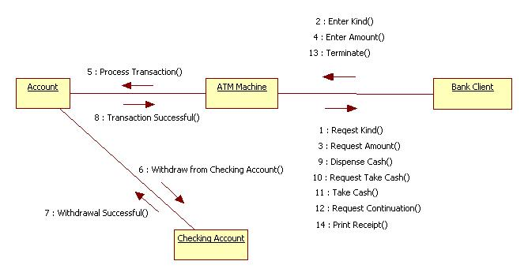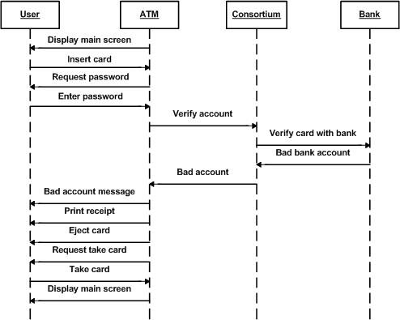

**2.4 COLLABRATION DIAGRAM**

**2.5 USE CASE DIAGRAM**

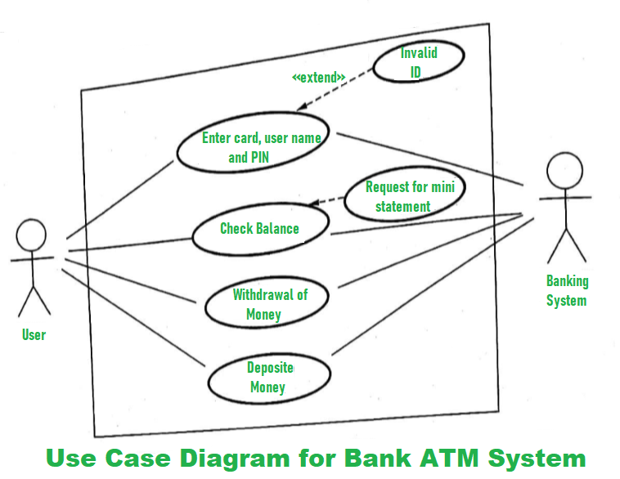

**2.6 STATE CHART DIAGRAM**

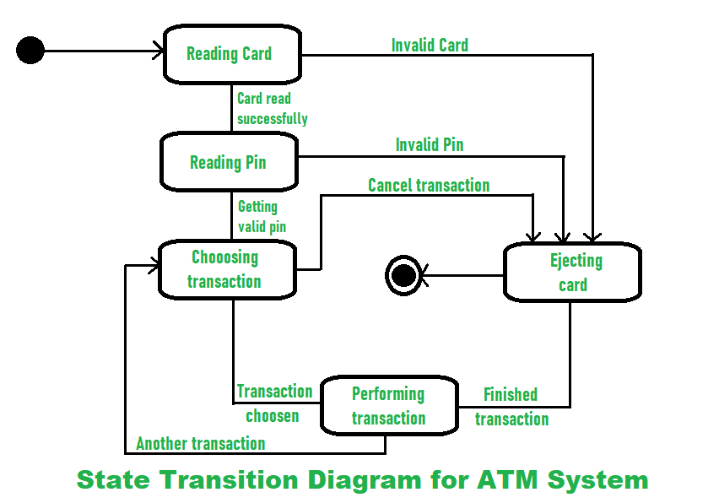

**CHAPTER 3**

**OUTPUT:**

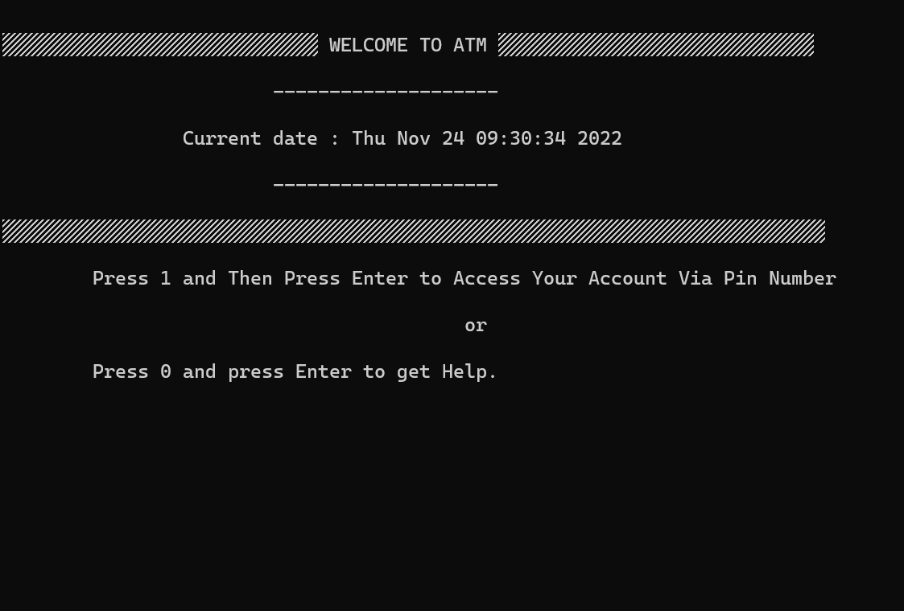

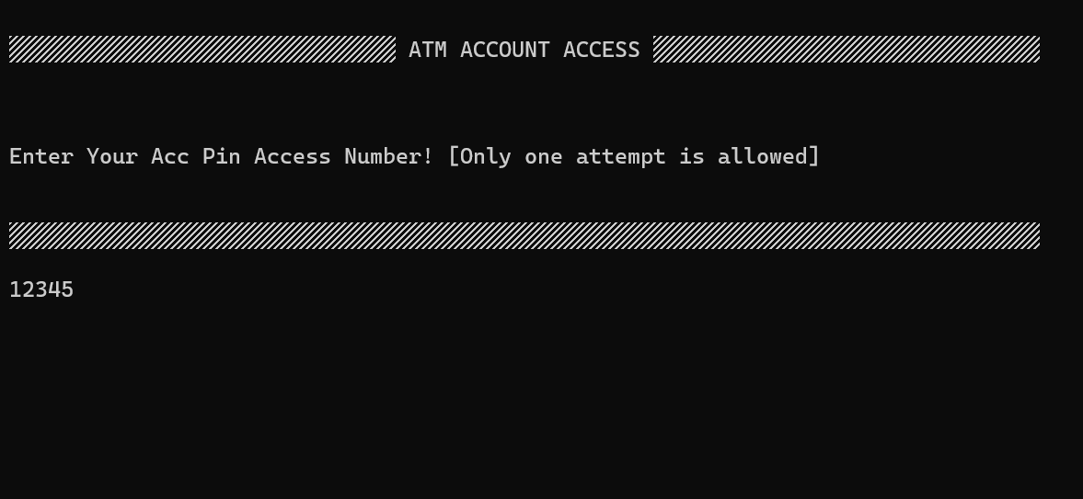

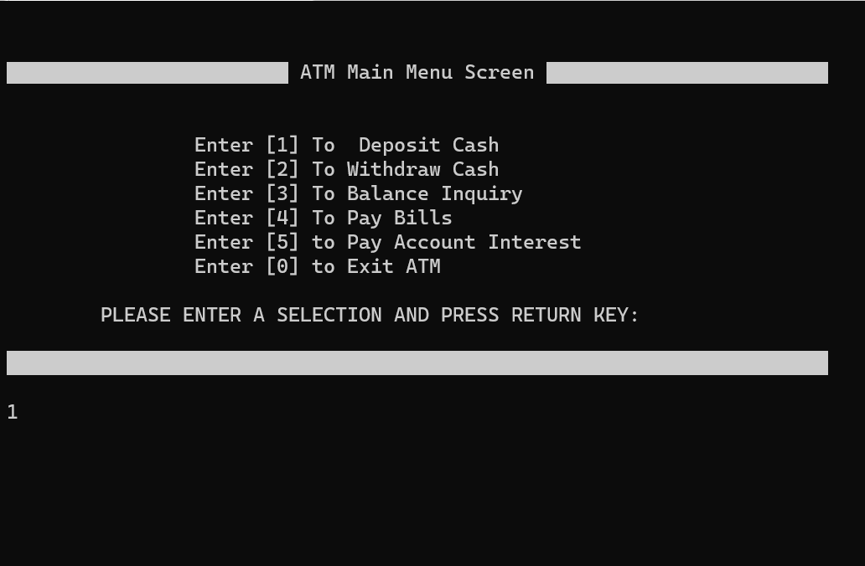

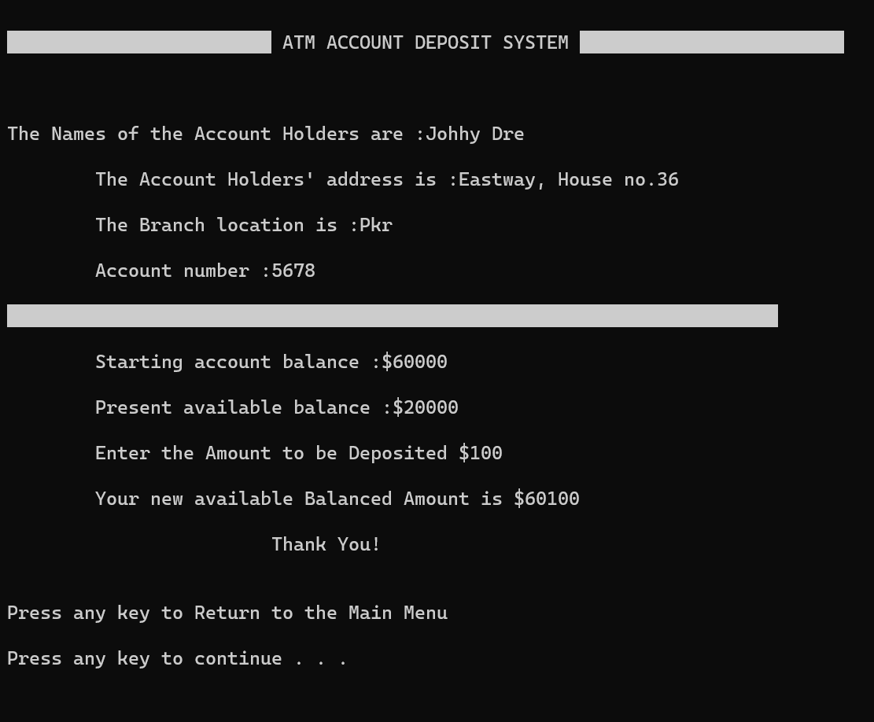

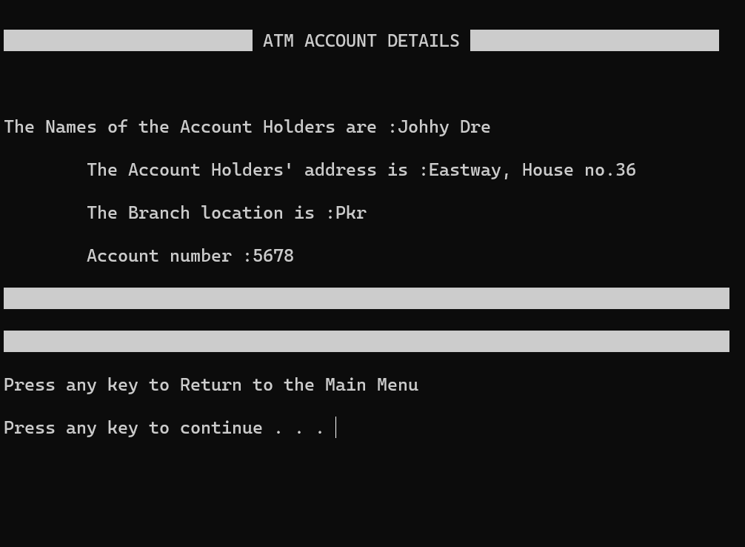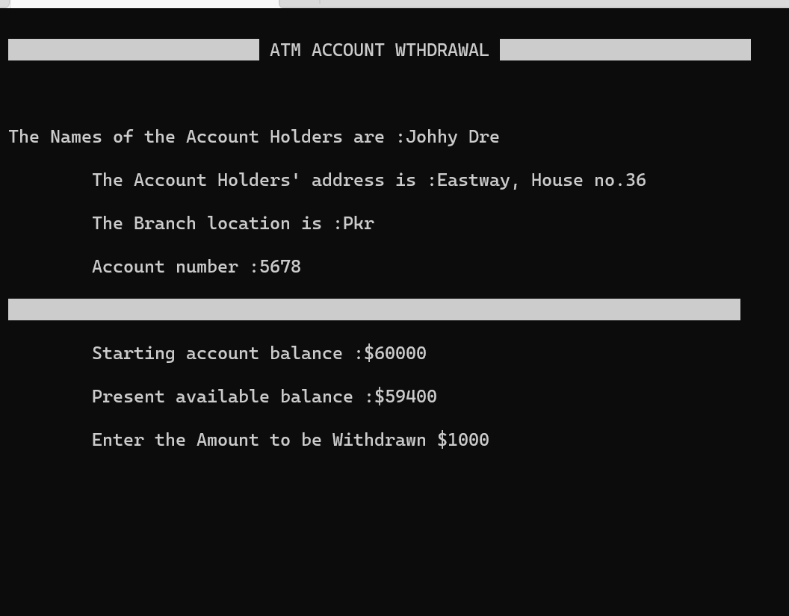

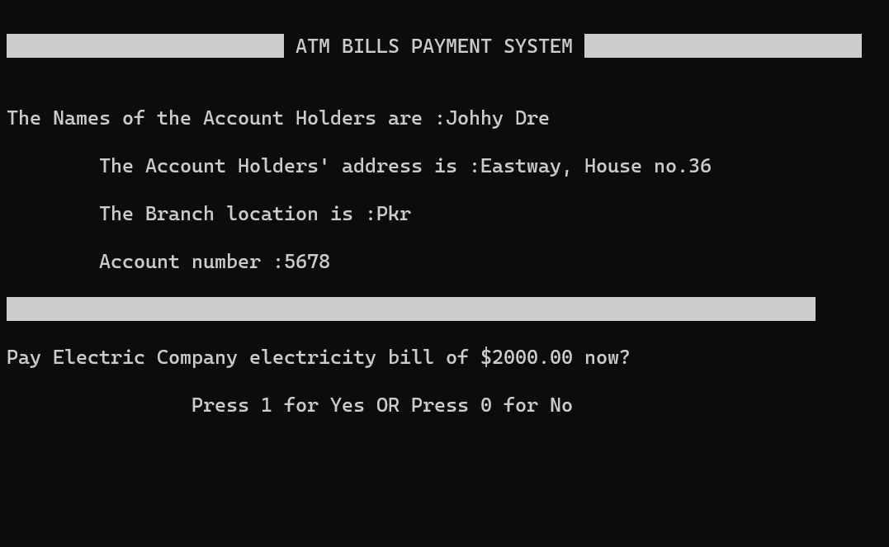

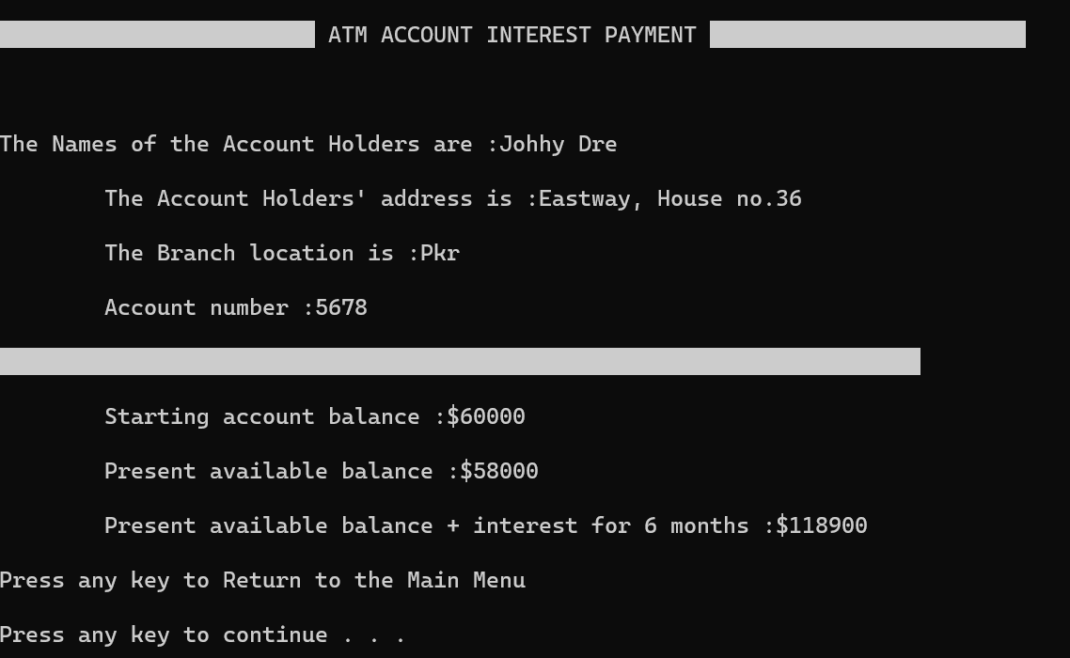

**CHAPTER 4**

**Conclusion and Future Enhancement**

**Future Enhancements**

* Loan Facility
* Email and mobile alerts.
* Active Tracing of Fraudulent activities
* Security upgrades like Visual Sensors with burglar alarms, Biometric Identification procedures etc.

**Conclusion:**

From this presentation, one can observe that an ATM system is associated with the bank transactions of the consumers. Majorly, the ATM system is utilized for the money associated transactions from the consumers. Consumers make major use of ATM to withdraw money from their bank account. It is a fast way to get money out of your account, especially when on the go or during atrip

**APPENDIX**

**CODE:**

#include <iostream>

#include <iomanip>

#include <time.h>

#include <fstream>

#include <conio.h>

#include <string.h>

#include <stdlib.h>

#include<process.h>

#include<dos.h>

using namespace std;

class Bank //abstract base class

{

public:

double startBalance;

string COKAccountHolders;

double limit;

};

class ATMAccountHolders:public Bank

{

string accountHolders;

string accountHoldersAddress, branch;

int accountNumber;

double startBalance;

double accountBalance;

double accountInterest;

double amount;

int count;

public:

//void Display_accountBalance();

void deposit();

void withdraw();

void details();

void payBills();

void accountExit();

void interest();

ATMAccountHolders()

{

accountNumber = 5678;

accountHolders = "Johhy Dre";

accountHoldersAddress = "Eastway, House no.36";

startBalance = 60000.00;

accountBalance = 20000.00;

branch = "Pkr";

amount = 20000;

}

};

void ATMAccountHolders::interest()

{

system("cls");

cout<<"\n\xB2\xB2\xB2\xB2\\xB2\xB2\xB2\xB2\ATM ACCOUNT INTEREST PAYMENT\xB2\xB2\xB2\xB2\\xB2\xB2\xB2\xB2\\n\n";

cout<<"\tThe Interest is calculate over the last SIX months on the average account balance\n";

cout<<"\n\t\tInterest Rate payable is 10% per annum."<<endl;

cout<<"\t\tView the accumulated interest? Press 1 for Yes OR 0 for NO.\n\n";

cout<<"\xdb\xdb\xdb\xdb\xdb\xdb\xdb\xdb\xdb\xdb\xdb\xdb\xdb\xdb\xdb\xdb\xdb\xdb\xdb\xdb\xdb\xdb\xdb\xdb ATM ACCOUNT INTEREST PAYMENT \xdb\xdb\xdb\xdb\xdb\xdb\xdb\xdb\xdb\xdb\xdb\xdb\xdb\xdb\xdb\xdb\xdb\xdb\xdb\xdb\xdb\xdb\xdb\xdb\n\n";

cout<<"\n\nThe Names of the Account Holders are :"<<accountHolders<<"\n\n";

cout<<"\tThe Account Holders' address is :"<<accountHoldersAddress<<"\n\n";

cout<<"\tThe Branch location is :"<<branch<<"\n\n";

cout<<"\tAccount number :"<<accountNumber<<"\n\n";

cout<<"\xdb\xdb\xdb\xdb\xdb\xdb\xdb\xdb\xdb\xdb\xdb\xdb\xdb\xdb\xdb\xdb\xdb\xdb\xdb\xdb\xdb\xdb\xdb\xdb\xdb\xdb\xdb\xdb\xdb\xdb\xdb\xdb\xdb\xdb\xdb\xdb\xdb\xdb\xdb\xdb\xdb\xdb\xdb\xdb\xdb\xdb\xdb\xdb\xdb\xdb\xdb\xdb\xdb\xdb\xdb\xdb\xdb\xdb\xdb\xdb\xdb\xdb\xdb\xdb\xdb\xdb\xdb\xdb\xdb\xdb\n\n";

cout<<"\tStarting account balance :$"<<startBalance<<"\n\n";

cout<<"\tPresent available balance :$"<<accountBalance<<"\n\n";

accountInterest=accountBalance+(accountBalance*1.050);

cout<<"\tPresent available balance + interest for 6 months :$"<<accountInterest<<"\n\n";

cout<<"Press any key to Return to the Main Menu\n\n";

system("PAUSE");

}

void ATMAccountHolders::deposit()

{

system("cls");

cout<<"\n\xdb\xdb\xdb\xdb\xdb\xdb\xdb\xdb\xdb\xdb\xdb\xdb\xdb\xdb\xdb\xdb\xdb\xdb\xdb\xdb\xdb\xdb\xdb\xdb ATM ACCOUNT DEPOSIT SYSTEM \xdb\xdb\xdb\xdb\xdb\xdb\xdb\xdb\xdb\xdb\xdb\xdb\xdb\xdb\xdb\xdb\xdb\xdb\xdb\xdb\xdb\xdb\xdb\xdb\n\n";

cout<<"\n\nThe Names of the Account Holders are :"<<accountHolders<<"\n\n";

cout<<"\tThe Account Holders' address is :"<<accountHoldersAddress<<"\n\n";

cout<<"\tThe Branch location is :"<<branch<<"\n\n";

cout<<"\tAccount number :"<<accountNumber<<"\n\n";

cout<<"\xdb\xdb\xdb\xdb\xdb\xdb\xdb\xdb\xdb\xdb\xdb\xdb\xdb\xdb\xdb\xdb\xdb\xdb\xdb\xdb\xdb\xdb\xdb\xdb\xdb\xdb\xdb\xdb\xdb\xdb\xdb\xdb\xdb\xdb\xdb\xdb\xdb\xdb\xdb\xdb\xdb\xdb\xdb\xdb\xdb\xdb\xdb\xdb\xdb\xdb\xdb\xdb\xdb\xdb\xdb\xdb\xdb\xdb\xdb\xdb\xdb\xdb\xdb\xdb\xdb\xdb\xdb\xdb\xdb\xdb\n\n";

cout<<"\tStarting account balance :$"<<startBalance<<"\n\n";

cout<<"\tPresent available balance :$"<<accountBalance<<"\n\n";

cout<<"\tEnter the Amount to be Deposited $";

double amount;

cin>>amount;

accountBalance=startBalance+amount ;

cout<<"\n\tYour new available Balanced Amount is $"<<accountBalance<<endl ;

cout<<"\n\t\t\tThank You!\n\n"<<endl;

cout<<"Press any key to Return to the Main Menu\n\n";

system("PAUSE");

}

void ATMAccountHolders::withdraw()//Withdrawal Transactions

{

system("cls");

cout<<"\n\xdb\xdb\xdb\xdb\xdb\xdb\xdb\xdb\xdb\xdb\xdb\xdb\xdb\xdb\xdb\xdb\xdb\xdb\xdb\xdb\xdb\xdb\xdb\xdb ATM ACCOUNT WTHDRAWAL \xdb\xdb\xdb\xdb\xdb\xdb\xdb\xdb\xdb\xdb\xdb\xdb\xdb\xdb\xdb\xdb\xdb\xdb\xdb\xdb\xdb\xdb\xdb\xdb\n\n";

cout<<"\n\nThe Names of the Account Holders are :"<<accountHolders<<"\n\n";

cout<<"\tThe Account Holders' address is :"<<accountHoldersAddress<<"\n\n";

cout<<"\tThe Branch location is :"<<branch<<"\n\n";

cout<<"\tAccount number :"<<accountNumber<<"\n\n";

cout<<"\xdb\xdb\xdb\xdb\xdb\xdb\xdb\xdb\xdb\xdb\xdb\xdb\xdb\xdb\xdb\xdb\xdb\xdb\xdb\xdb\xdb\xdb\xdb\xdb\xdb\xdb\xdb\xdb\xdb\xdb\xdb\xdb\xdb\xdb\xdb\xdb\xdb\xdb\xdb\xdb\xdb\xdb\xdb\xdb\xdb\xdb\xdb\xdb\xdb\xdb\xdb\xdb\xdb\xdb\xdb\xdb\xdb\xdb\xdb\xdb\xdb\xdb\xdb\xdb\xdb\xdb\xdb\xdb\xdb\xdb\n\n";

cout<<"\tStarting account balance :$"<<startBalance<<"\n\n";

cout<<"\tPresent available balance :$"<<accountBalance<<"\n\n";

cout<<"\tEnter the Amount to be Withdrawn $";

double amount;

cin>>amount;

if(amount>accountBalance||amount>9000)//Limit set at $9000 maximum after paying bills

{

system("cls");

cout<<"\n\xdb\xdb\xdb\xdb\xdb\xdb\xdb\xdb\xdb\xdb\xdb\xdb\xdb\xdb\xdb\xdb\xdb\xdb\xdb\xdb\xdb\xdb\xdb\xdb ATM ACCOUNT WITHDRAWAL \xdb\xdb\xdb\xdb\xdb\xdb\xdb\xdb\xdb\xdb\xdb\xdb\xdb\xdb\xdb\xdb\xdb\xdb\xdb\xdb\xdb\xdb\xdb\xdb\n\n";

cout<<"\n\nThe Names of the Account Holders are :"<<accountHolders<<"\n\n";

cout<<"\tThe Account Holders' address is :"<<accountHoldersAddress<<"\n\n";

cout<<"\tThe Branch location is :"<<branch<<"\n\n";

cout<<"\tAccount number :"<<accountNumber<<"\n\n";

cout<<"\xdb\xdb\xdb\xdb\xdb\xdb\xdb\xdb\xdb\xdb\xdb\xdb\xdb\xdb\xdb\xdb\xdb\xdb\xdb\xdb\xdb\xdb\xdb\xdb\xdb\xdb\xdb\xdb\xdb\xdb\xdb\xdb\xdb\xdb\xdb\xdb\xdb\xdb\xdb\xdb\xdb\xdb\xdb\xdb\xdb\xdb\xdb\xdb\xdb\xdb\xdb\xdb\xdb\xdb\xdb\xdb\xdb\xdb\xdb\xdb\xdb\xdb\xdb\xdb\xdb\xdb\xdb\xdb\xdb\xdb\n\n";

cout<<"\n\tInsufficient Available Balance in your account.\n\n"<<endl;

cout<<"\t\t\tSorry !!\n"<<endl;

system("PAUSE");

}

else

{

double b;

accountBalance=startBalance-amount ;

system("cls");

cout<<"\n\xdb\xdb\xdb\xdb\xdb\xdb\xdb\xdb\xdb\xdb\xdb\xdb\xdb\xdb\xdb\xdb\xdb\xdb\xdb\xdb\xdb\xdb\xdb\xdb ATM ACCOUNT WTHDRAWAL \xdb\xdb\xdb\xdb\xdb\xdb\xdb\xdb\xdb\xdb\xdb\xdb\xdb\xdb\xdb\xdb\xdb\xdb\xdb\xdb\xdb\xdb\xdb\xdb\n\n";

cout<<"\n\nThe Names of the Account Holders are :"<<accountHolders<<"\n\n";

cout<<"\tThe Account Holders' address is :"<<accountHoldersAddress<<"\n\n";

cout<<"\tThe Branch location is :"<<branch<<"\n\n";

cout<<"\tAccount number :"<<accountNumber<<"\n\n";

cout<<"\xdb\xdb\xdb\xdb\xdb\xdb\xdb\xdb\xdb\xdb\xdb\xdb\xdb\xdb\xdb\xdb\xdb\xdb\xdb\xdb\xdb\xdb\xdb\xdb\xdb\xdb\xdb\xdb\xdb\xdb\xdb\xdb\xdb\xdb\xdb\xdb\xdb\xdb\xdb\xdb\xdb\xdb\xdb\xdb\xdb\xdb\xdb\xdb\xdb\xdb\xdb\xdb\xdb\xdb\xdb\xdb\xdb\xdb\xdb\xdb\xdb\xdb\xdb\xdb\xdb\xdb\xdb\xdb\xdb\xdb\n\n";

cout<<"Your new available Balanced Amount is $"<<accountBalance<<endl ;

cout<<"Press any key to Return to the Main Menu\n\n";

system("PAUSE");

}

}

void ATMAccountHolders::payBills()

{

system("cls");

cout<<"\n\xdb\xdb\xdb\xdb\xdb\xdb\xdb\xdb\xdb\xdb\xdb\xdb\xdb\xdb\xdb\xdb\xdb\xdb\xdb\xdb\xdb\xdb\xdb\xdb ATM BILLS PAYMENT SYSTEM \xdb\xdb\xdb\xdb\xdb\xdb\xdb\xdb\xdb\xdb\xdb\xdb\xdb\xdb\xdb\xdb\xdb\xdb\xdb\xdb\xdb\xdb\xdb\xdb\n";

cout<<"\n\nThe Names of the Account Holders are :"<<accountHolders<<"\n\n";

cout<<"\tThe Account Holders' address is :"<<accountHoldersAddress<<"\n\n";

cout<<"\tThe Branch location is :"<<branch<<"\n\n";

cout<<"\tAccount number :"<<accountNumber<<"\n\n";

cout<<"\xdb\xdb\xdb\xdb\xdb\xdb\xdb\xdb\xdb\xdb\xdb\xdb\xdb\xdb\xdb\xdb\xdb\xdb\xdb\xdb\xdb\xdb\xdb\xdb\xdb\xdb\xdb\xdb\xdb\xdb\xdb\xdb\xdb\xdb\xdb\xdb\xdb\xdb\xdb\xdb\xdb\xdb\xdb\xdb\xdb\xdb\xdb\xdb\xdb\xdb\xdb\xdb\xdb\xdb\xdb\xdb\xdb\xdb\xdb\xdb\xdb\xdb\xdb\xdb\xdb\xdb\xdb\xdb\xdb\xdb\n\n";

cout<<"Pay Electric Company electricity bill of $2000.00 now?\n\n";

cout<<"\t\tPress 1 for Yes OR Press 0 for No\n\n";

int r;

cin>>r;

if(r=1)

{accountBalance=startBalance-2000;

system("cls");

cout<<"\n\xdb\xdb\xdb\xdb\xdb\xdb\xdb\xdb\xdb\xdb\xdb\xdb\xdb\xdb\xdb\xdb\xdb\xdb\xdb\xdb\xdb\xdb\xdb\xdb ATM BILLS PAYMENT SYSTEM \xdb\xdb\xdb\xdb\xdb\xdb\xdb\xdb\xdb\xdb\xdb\xdb\xdb\xdb\xdb\xdb\xdb\xdb\xdb\xdb\xdb\xdb\xdb\xdb\n";

cout<<"\n\tYour electricity bill of $2000.00 has been paid.\n\n";

cout<<"\tYour account new Available Balanced Amount is $"<<accountBalance<<endl ;

cout<<"\n\xdb\xdb\xdb\xdb\xdb\xdb\xdb\xdb\xdb\xdb\xdb\xdb\xdb\xdb\xdb\xdb\xdb\xdb\xdb\xdb\xdb\xdb\xdb\xdb\xdb\xdb\xdb\xdb\xdb\xdb\xdb\xdb\xdb\xdb\xdb\xdb\xdb\xdb\xdb\xdb\xdb\xdb\xdb\xdb\xdb\xdb\xdb\xdb\xdb\xdb\xdb\xdb\xdb\xdb\xdb\xdb\xdb\xdb\xdb\xdb\xdb\xdb\xdb\xdb\xdb\xdb\xdb\xdb\xdb\xdb\n\n";

cout<<"Press any key to Return to the Main Menu\n\n";

}

if(r=0)

{

cout<<"\n===========================ATM BILLS PAYMENT SYSTEM==========================\n\n";

cout<<"\n\n\tExiting Bill Payment System. Thank you!.\n\n";

cout<<"====================++THANK YOU++============================\n\n";

}

system("PAUSE");

};

void ATMAccountHolders::details()

{

system("cls");

cout<<"\n\xdb\xdb\xdb\xdb\xdb\xdb\xdb\xdb\xdb\xdb\xdb\xdb\xdb\xdb\xdb\xdb\xdb\xdb\xdb\xdb\xdb\xdb\xdb\xdb ATM ACCOUNT DETAILS \xdb\xdb\xdb\xdb\xdb\xdb\xdb\xdb\xdb\xdb\xdb\xdb\xdb\xdb\xdb\xdb\xdb\xdb\xdb\xdb\xdb\xdb\xdb\xdb\n\n";

cout<<"\n\nThe Names of the Account Holders are :"<<accountHolders<<"\n\n";

cout<<"\tThe Account Holders' address is :"<<accountHoldersAddress<<"\n\n";

cout<<"\tThe Branch location is :"<<branch<<"\n\n";

cout<<"\tAccount number :"<<accountNumber<<"\n\n";

cout<<"\xdb\xdb\xdb\xdb\xdb\xdb\xdb\xdb\xdb\xdb\xdb\xdb\xdb\xdb\xdb\xdb\xdb\xdb\xdb\xdb\xdb\xdb\xdb\xdb\xdb\xdb\xdb\xdb\xdb\xdb\xdb\xdb\xdb\xdb\xdb\xdb\xdb\xdb\xdb\xdb\xdb\xdb\xdb\xdb\xdb\xdb\xdb\xdb\xdb\xdb\xdb\xdb\xdb\xdb\xdb\xdb\xdb\xdb\xdb\xdb\xdb\xdb\xdb\xdb\xdb\xdb\xdb\xdb\xdb\xdb\n\n";

cout<<"\xdb\xdb\xdb\xdb\xdb\xdb\xdb\xdb\xdb\xdb\xdb\xdb\xdb\xdb\xdb\xdb\xdb\xdb\xdb\xdb\xdb\xdb\xdb\xdb\xdb\xdb\xdb\xdb\xdb\xdb\xdb\xdb\xdb\xdb\xdb\xdb\xdb\xdb\xdb\xdb\xdb\xdb\xdb\xdb\xdb\xdb\xdb\xdb\xdb\xdb\xdb\xdb\xdb\xdb\xdb\xdb\xdb\xdb\xdb\xdb\xdb\xdb\xdb\xdb\xdb\xdb\xdb\xdb\xdb\xdb\n\n";

cout<<"Press any key to Return to the Main Menu\n\n";

system("PAUSE");

}

void ATMAccountHolders::accountExit()

{

system("cls");

cout<<"\n\xB2\xB2\xB2\xB2\xB2\xB2\xB2\xB2\xB2\xB2\xB2\xB2\xB2\xB2\xB2\xB2\xB2\xB2\xB2\xB2\xB2\xB2\xB2\xB2\xB2\xB2\xB2\xB2\ ATM ACCOUNT EXIT \xB2\xB2\xB2\xB2\xB2\xB2\xB2\xB2\xB2\xB2\xB2\xB2\xB2\xB2\xB2\xB2\xB2\xB2\xB2\xB2\xB2\xB2\xB2\xB2\xB2\xB2\xB2\xB2\n\n";

cout<<"\n\n\t\t BROUGHT TO YOU BY CODE-PROJECTS \n\n";

cout<<"\xB2\xB2\xB2\xB2\xB2\xB2\xB2\xB2\xB2\xB2\xB2\xB2\xB2\xB2\xB2\xB2\xB2\xB2\xB2\xB2\xB2\xB2\xB2\xB2\xB2\xB2\xB2\xB2\xB2\xB2\xB2\xB2\xB2\xB2\xB2\xB2\xB2\xB2\xB2\xB2\xB2\xB2\xB2\xB2\xB2\xB2\xB2\xB2\xB2\xB2\xB2\xB2\xB2\xB2\xB2\xB2\xB2\xB2\xB2\xB2\xB2\xB2\xB2\xB2\xB2\xB2\xB2\xB2\xB2\xB2\xB2\xB2\xB2\n\n";

system("PAUSE");

exit(1);

}

class Limits:public Bank

{

public:

void SetLimit(double NewLimit)

{}

double Getlimit()

{}

};

int main()

{

int e;

ATMAccountHolders p;

cout<<"\n\xB2\xB2\xB2\xB2\xB2\xB2\xB2\xB2\xB2\xB2\xB2\xB2\xB2\xB2\xB2\xB2\xB2\xB2\xB2\xB2\xB2\xB2\xB2\xB2\xB2\xB2\xB2\xB2\ WELCOME TO ATM \xB2\xB2\xB2\xB2\xB2\xB2\xB2\xB2\xB2\xB2\xB2\xB2\xB2\xB2\xB2\xB2\xB2\xB2\xB2\xB2\xB2\xB2\xB2\xB2\xB2\xB2\xB2\xB2\n\n";

cout<<"\t\t\t--------------------\n"<<endl;

//Prompt to show today's date

cout << "\t\tCurrent date : ";

//Show date and time function

time_t now;

time(&now);

printf("%s\n", ctime(&now));;

//Give space for the function of date and time

cout<<"\t\t\t--------------------\n"<<endl;

cout<<"\xB2\xB2\xB2\xB2\xB2\xB2\xB2\xB2\xB2\xB2\xB2\xB2\xB2\xB2\xB2\xB2\xB2\xB2\xB2\xB2\xB2\xB2\xB2\xB2\xB2\xB2\xB2\xB2\xB2\xB2\xB2\xB2\xB2\xB2\xB2\xB2\xB2\xB2\xB2\xB2\xB2\xB2\xB2\xB2\xB2\xB2\xB2\xB2\xB2\xB2\xB2\xB2\xB2\xB2\xB2\xB2\xB2\xB2\xB2\xB2\xB2\xB2\xB2\xB2\xB2\xB2\xB2\xB2\xB2\xB2\xB2\xB2\xB2\n\n";

cout<<"\tPress 1 and Then Press Enter to Access Your Account Via Pin Number\n\n";

cout<<"\t\t\t\t\t or \n\n";

cout<<"\tPress 0 and press Enter to get Help.\n\n";

int access;

cin>>access;

switch(access)

{

case 1://pin to access account

system("cls");int i, pin;

cout<<"\n\xB2\xB2\xB2\xB2\xB2\xB2\xB2\xB2\xB2\xB2\xB2\xB2\xB2\xB2\xB2\xB2\xB2\xB2\xB2\xB2\xB2\xB2\xB2\xB2\xB2\xB2\xB2\xB2\xB2\xB2 ATM ACCOUNT ACCESS \xB2\xB2\xB2\xB2\xB2\xB2\xB2\xB2\xB2\xB2\xB2\xB2\xB2\xB2\xB2\xB2\xB2\xB2\xB2\xB2\xB2\xB2\xB2\xB2\xB2\xB2\xB2\xB2\xB2\xB2\n\n";

cout<<"\n\nEnter Your Acc Pin Access Number! [Only one attempt is allowed]\n\n"<<endl;

cout<<"\xB2\xB2\xB2\xB2\xB2\xB2\xB2\xB2\xB2\xB2\xB2\xB2\xB2\xB2\xB2\xB2\xB2\xB2\xB2\xB2\xB2\xB2\xB2\xB2\xB2\xB2\xB2\xB2\xB2\xB2\xB2\xB2\xB2\xB2\xB2\xB2\xB2\xB2\xB2\xB2\xB2\xB2\xB2\xB2\xB2\xB2\xB2\xB2\xB2\xB2\xB2\xB2\xB2\xB2\xB2\xB2\xB2\xB2\xB2\xB2\xB2\xB2\xB2\xB2\xB2\xB2\xB2\xB2\xB2\xB2\xB2\xB2\xB2\xB2\xB2\xB2\xB2\xB2\xB2\xB2\n\n";

cin>>pin;

system("cls");

if(pin==12345)

{

system("cls");

do

{

system("cls");

cout << endl << "\n\xdb\xdb\xdb\xdb\xdb\xdb\xdb\xdb\xdb\xdb\xdb\xdb\xdb\xdb\xdb\xdb\xdb\xdb\xdb\xdb\xdb\xdb\xdb\xdb ATM Main Menu Screen \xdb\xdb\xdb\xdb\xdb\xdb\xdb\xdb\xdb\xdb\xdb\xdb\xdb\xdb\xdb\xdb\xdb\xdb\xdb\xdb\xdb\xdb\xdb\xdb\n" << endl << endl;

cout << "\t\tEnter [1] To Deposit Cash" << endl;

cout << "\t\tEnter [2] To Withdraw Cash" << endl;

cout << "\t\tEnter [3] To Balance Inquiry" << endl;

cout << "\t\tEnter [4] To Pay Bills" << endl;

cout << "\t\tEnter [5] to Pay Account Interest" << endl;

cout << "\t\tEnter [0] to Exit ATM" << endl << endl;

cout << "\tPLEASE ENTER A SELECTION AND PRESS RETURN KEY: \n\n";

cout<<"\xdb\xdb\xdb\xdb\xdb\xdb\xdb\xdb\xdb\xdb\xdb\xdb\xdb\xdb\xdb\xdb\xdb\xdb\xdb\xdb\xdb\xdb\xdb\xdb\xdb\xdb\xdb\xdb\xdb\xdb\xdb\xdb\xdb\xdb\xdb\xdb\xdb\xdb\xdb\xdb\xdb\xdb\xdb\xdb\xdb\xdb\xdb\xdb\xdb\xdb\xdb\xdb\xdb\xdb\xdb\xdb\xdb\xdb\xdb\xdb\xdb\xdb\xdb\xdb\xdb\xdb\xdb\xdb\xdb\xdb\n\n";

cin>>e;

switch(e)

{

case 1:

p.deposit();

break;

case 2:

p.withdraw();

break;

case 3:

p.details();

break;

case 4:

p.payBills();

break;

case 5:

p.interest();

break;

case 0:

p.accountExit();

break;

default:cout<<"Please Enter the Correct Number Choice"<<endl;

}

}while(e!=0);

break;

}

else

{

system("cls");

cout<<"\n\xdb\xdb\xdb\xdb\xdb\xdb\xdb\xdb\xdb\xdb\xdb\xdb\xdb\xdb\xdb\xdb\xdb\xdb\xdb\xdb\xdb\xdb\xdb\xdb THANK YOU \xdb\xdb\xdb\xdb\xdb\xdb\xdb\xdb\xdb\xdb\xdb\xdb\xdb\xdb\xdb\xdb\xdb\xdb\xdb\xdb\xdb\xdb\xdb\xdb\n\n";

cout<<"\nYou had made your attempt which failed!!! No More attempts allowed!! Sorry!!\n\n";

cout<<"\xdb\xdb\xdb\xdb\xdb\xdb\xdb\xdb\xdb\xdb\xdb\xdb\xdb\xdb\xdb\xdb\xdb\xdb\xdb\xdb\xdb\xdb\xdb\xdb\xdb\xdb\xdb\xdb\xdb\xdb\xdb\xdb\xdb\xdb\xdb\xdb\xdb\xdb\xdb\xdb\xdb\xdb\xdb\xdb\xdb\xdb\xdb\xdb\xdb\xdb\xdb\xdb\xdb\xdb\xdb\xdb\xdb\xdb\xdb\n\n";

system("PAUSE");

exit (1);

}

case 0://pin to access account

system("cls");

cout<<"\n\xdb\xdb\xdb\xdb\xdb\xdb\xdb\xdb\xdb\xdb\xdb\xdb\xdb\xdb\xdb\xdb\xdb\xdb\xdb\xdb\xdb\xdb\xdb\xdb ATM ACCOUNT STATUS \xdb\xdb\xdb\xdb\xdb\xdb\xdb\xdb\xdb\xdb\xdb\xdb\xdb\xdb\xdb\xdb\xdb\xdb\xdb\xdb\xdb\xdb\xdb\xdb\n\n";

cout<<"\tYou must have the correct pin number to access this acount. See your\n\n";

cout<<"\t bank representative for assistance during bank opening hours\n\n";

cout<<"\t\tThanks for, your choice today!!\n\n";

cout<<"\xdb\xdb\xdb\xdb\xdb\xdb\xdb\xdb\xdb\xdb\xdb\xdb\xdb\xdb\xdb\xdb\xdb\xdb\xdb\xdb\xdb\xdb\xdb\xdb\xdb\xdb\xdb\xdb\xdb\xdb\xdb\xdb\xdb\xdb\xdb\xdb\xdb\xdb\xdb\xdb\xdb\xdb\xdb\xdb\xdb\xdb\xdb\xdb\xdb\xdb\xdb\xdb\xdb\xdb\xdb\xdb\xdb\xdb\xdb\xdb\xdb\xdb\xdb\xdb\xdb\xdb\xdb\xdb\n\n";

system ("PAUSE");

exit(1);

break;

}

system("PAUSE");

return 0;

};